Case Study 6

Task (1): User Interface Design

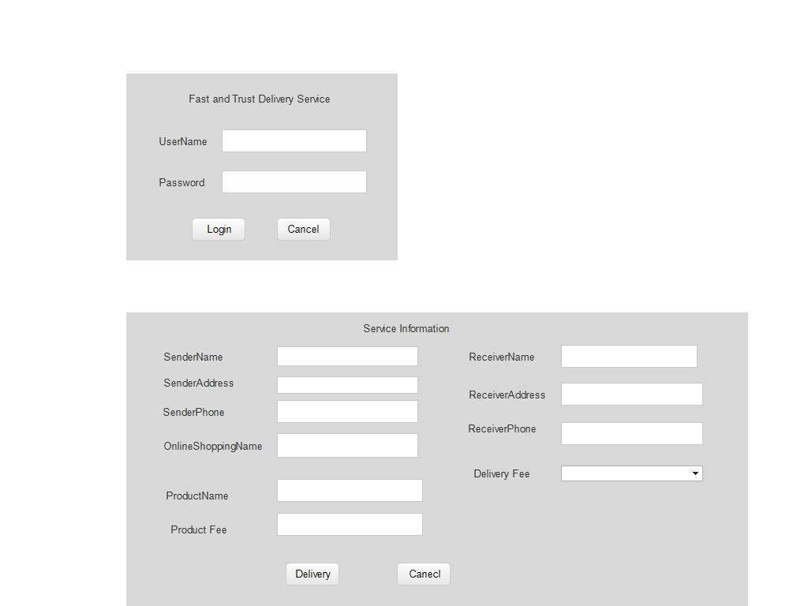

Task (2): Development

-Makes the ordering process easier

-Efficient customer and order management

-Monitor your expenses incurred in real time

-Free and cheap marketing

-Better customers data

-The convenience of mobile ordering

-Stay ahead of the competition

-Grow your bottom line

-greater reach

Task (3): Testing

-Unit Testing

-System Testing

-System Integration Testing

-User Acceptance Testing

-Regress Testing

Task (4): Test Data

Test Data Delivery is the process of creating a standardized and shared service to help testing teams get the business objects they need based on their specific criteria. Test Data Delivery helps bring clear efficiency into the testing process. The result is faster testing and faster application delivery.

Test Plan

-Analyse the product

-Design the Test Strategy

- Define the test Objectives

-Define Test Criteria

-Resource Planning

-Plan Test Environment

-Schedule & Estimation

-Determine test Deliverables

Maintenance Functions

-To develop maintenance policies, procedures and standards for the plant maintenance system.

-To ensure cost effective maintenance